I233018
LAB9

Q1.
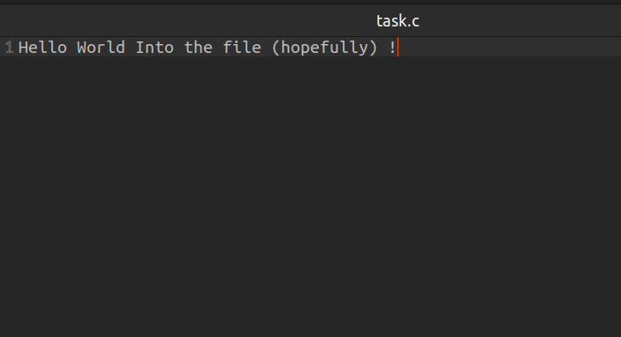

CODE:

#include <stdio.h>
#include <fcntl.h>
#include <unistd.h>

int main()
{
int fd = open("test.txt", O_WRONLY | O_CREAT | O_TRUNC, 0644);
if (fd < 0)
{
perror("open");
return 1;
}

int fd_dup=dup(fd);

if (dup2(fd_dup, 1) < 0)
{
perror("dup2");
return 1;
}

printf("Hello World Into the file (hopefully)\n");

close(fd);
return 0;
}

Q2:
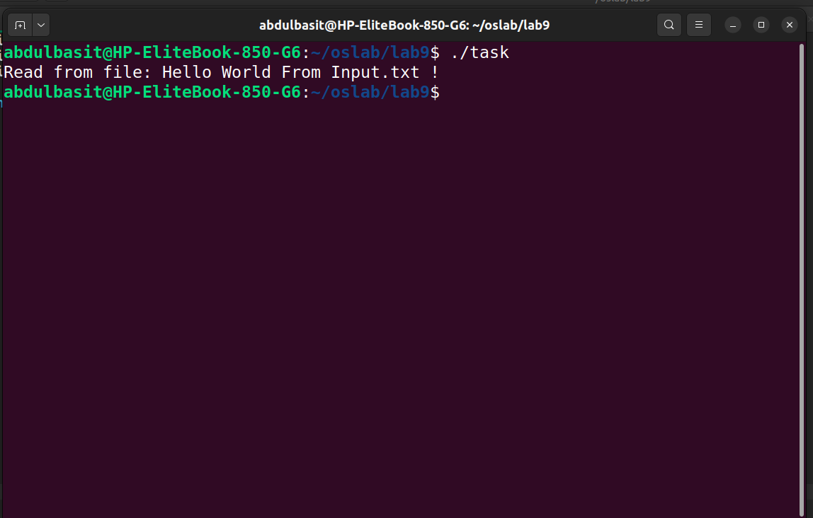
CODE:
#include <stdio.h>
#include <fcntl.h>
#include <unistd.h>

int main()
{

int fd = open("input.txt", O_RDONLY);
if (fd < 0)
{
perror("open");
return 1;
}

dup2(fd, 0);

char buffer[100];
fgets(buffer, sizeof(buffer), stdin);

printf("Read from file: %s", buffer);

close(fd);

return 0;
}

Q3:
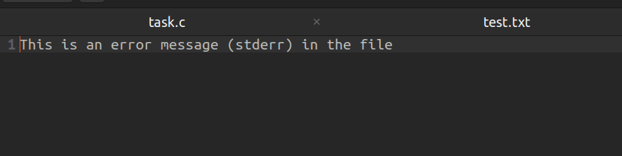
CODE:
#include <stdio.h>
#include <fcntl.h>
#include <unistd.h>

int main()
{
int fd = open("error.txt", O_WRONLY | O_CREAT | O_TRUNC, 0644);
if (fd < 0)
{
perror("open");
return 1;
}

dup2(fd, 2);

fprintf(stderr, "This is an error message (stderr) in the file\n");

close(fd);
return 0;
}

Q4:
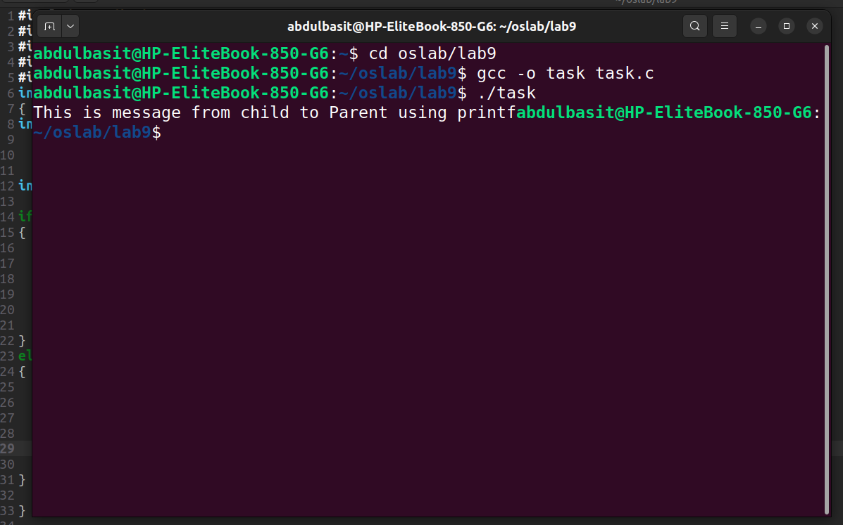

CODE:
#include <stdio.h>
#include <fcntl.h>
#include <unistd.h>
#include <sys/types.h>
#include <sys/wait.h>
int main()
{
int pipe1[2];
if(pipe(pipe1)==-1)
printf("Error in pipe");

int parent = fork();

if(parent==0)
{

close(pipe1[0]);
dup2(pipe1[1],1);
printf("This is message from child to Parent using printf");
close(pipe1[1]);

}
else
{
sleep(1);
close(pipe1[1]);
char buf[100];
ssize_t bytesRead = read(pipe1[0], buf, sizeof(buf) - 1);
buf[bytesRead] = '\0';
printf("%s",buf);
}

}

